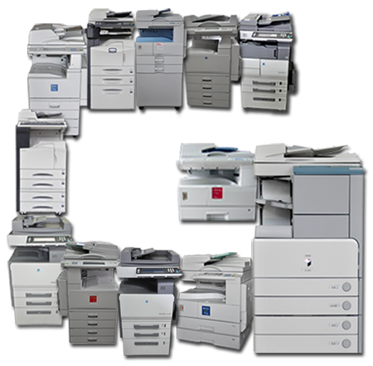

User Manual

Project Golden Cup

Bandong, Mary Allyson

Cuasay, Amiel Kristian

Embrador, Ronel

Magnaye, Corinne



2017

Table of Contents

1. Account Registration 1

2. Account Login 1

3. Placing an Item to Shopping Cart 2

4. Removing or Editing an Item from Shopping Cart 2

5. Checkout 3

6. Payment 3

# Account Registration

* One of the things necessary to use the ordering system is the User Account.
* To register, first, click the “Create an Account” link on the website’s home page.

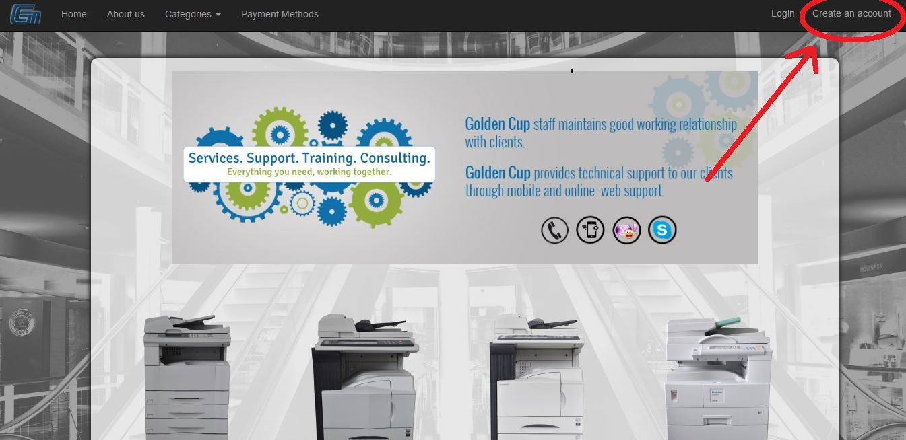

* Afterwards, you need to fill out the necessary details on the form that showed up from clicking the link.

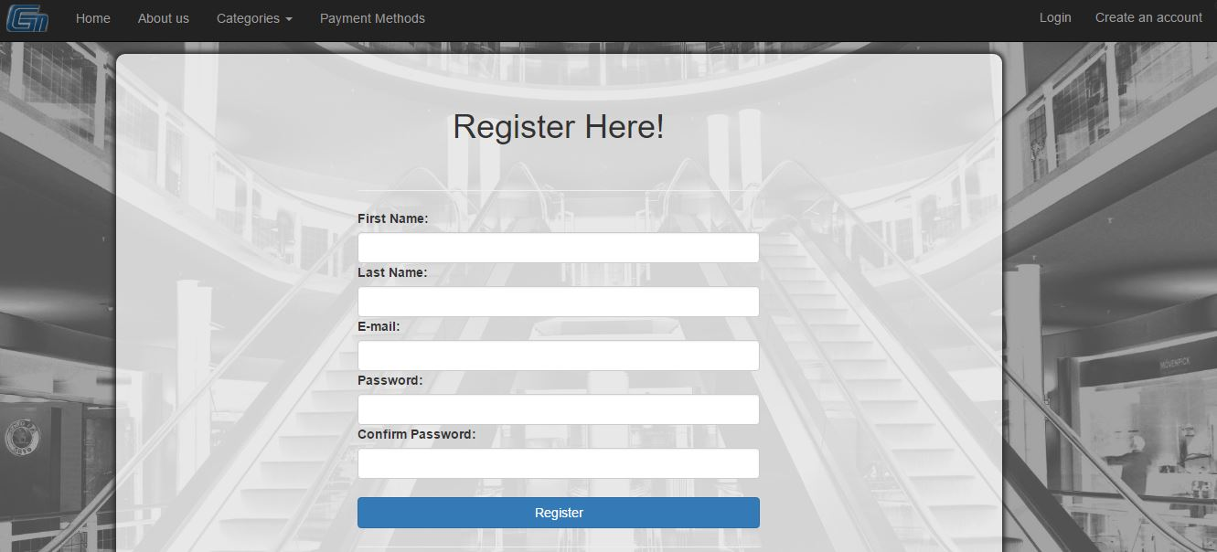

* When you have filled out all the details, click the “Register” button.

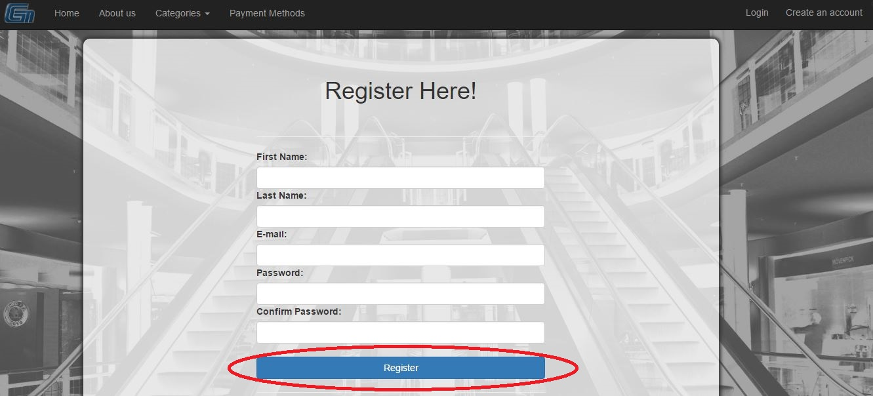

* If an error (the red section underneath the register button) happens, kindly refill the form and make sure that all the information you have filled out is correct and valid.

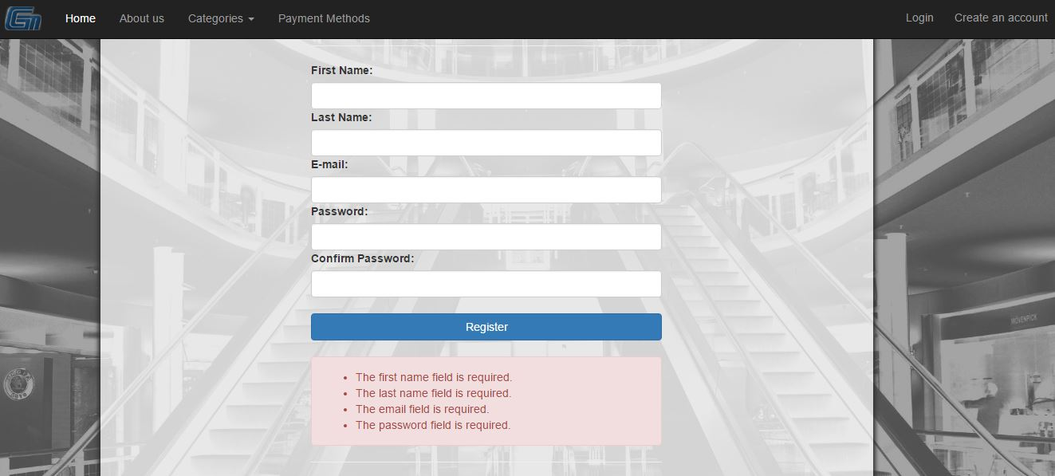

# Account Login

* One of the things necessary to use the ordering system is the User Account.
* To login, first, click the “Login” link on the website’s home page.

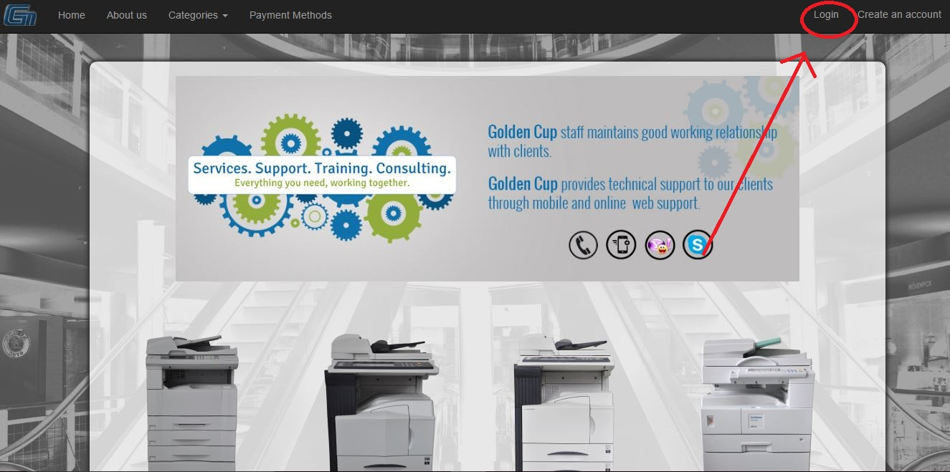

* Type the email that you registered with and your password

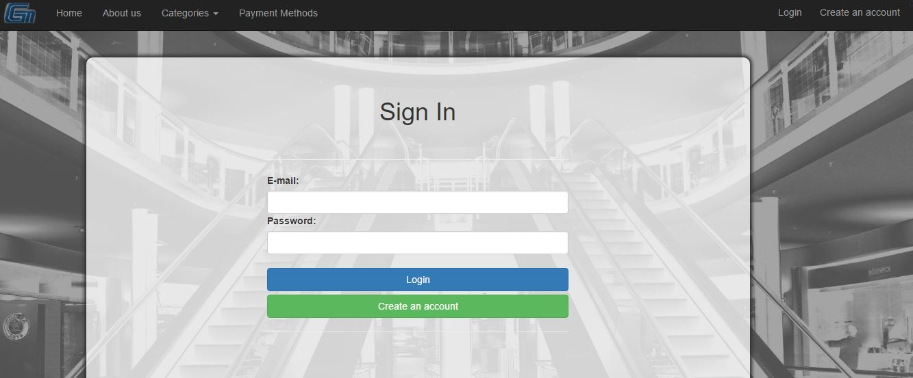

* If an error occurs, double check and make sure that the email and password that you have typed are correct and check your capitalization and it may be possible you left your caps lock on.

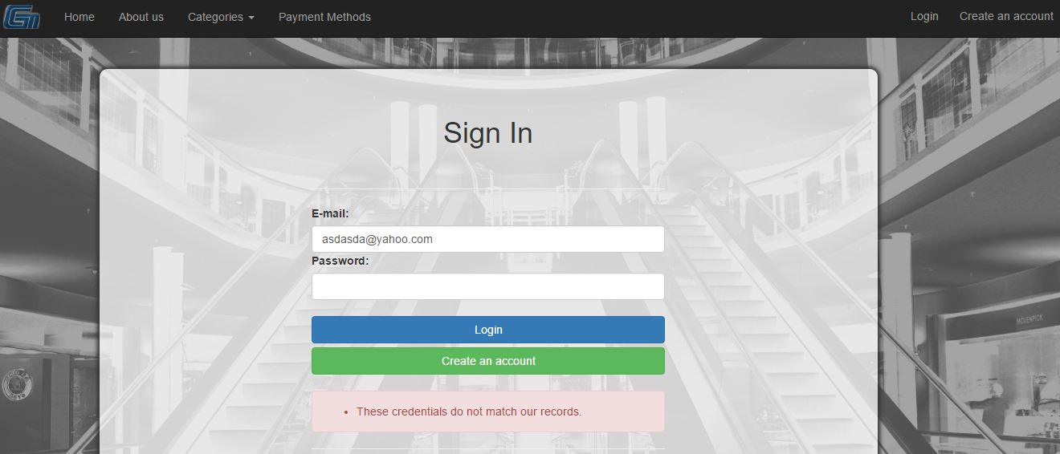



# Placing an Item to Shopping Cart

* To place an item to the shopping cart, first, navigate to the product page where the item you desire to buy is located in.
* Located on the lower left of the details of the product is an “Add to cart” button.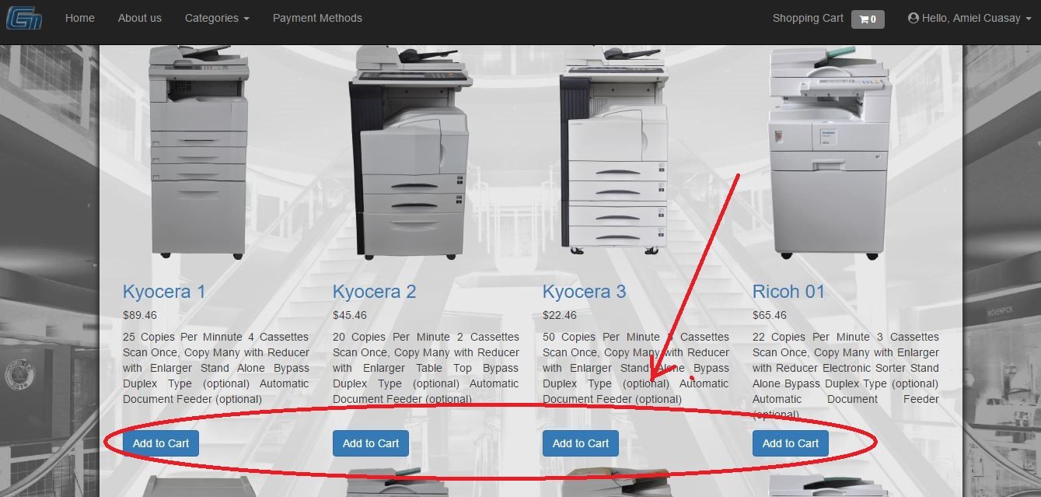
* Click the “Add to cart” button of the product that you wish to buy and you should see that the number beside the shopping cart icon has increased, this signifies that the product you have chosen has been added to your shopping cart.

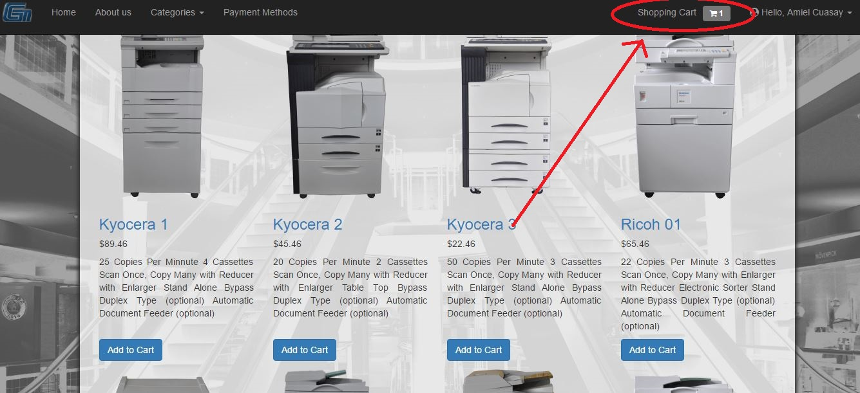

# Removing or Editing an Item from Shopping Cart

* To remove/edit an item from your shopping cart, first, there needs to be an item in your shopping cart. This is signified by the number beside the shopping cart icon and if it is not 0, this means that there is an item placed inside.
* You can see the items in your shopping cart by clicking the shopping cart icon. This will bring you to a page with the details of all the items that are currently in your shopping cart.

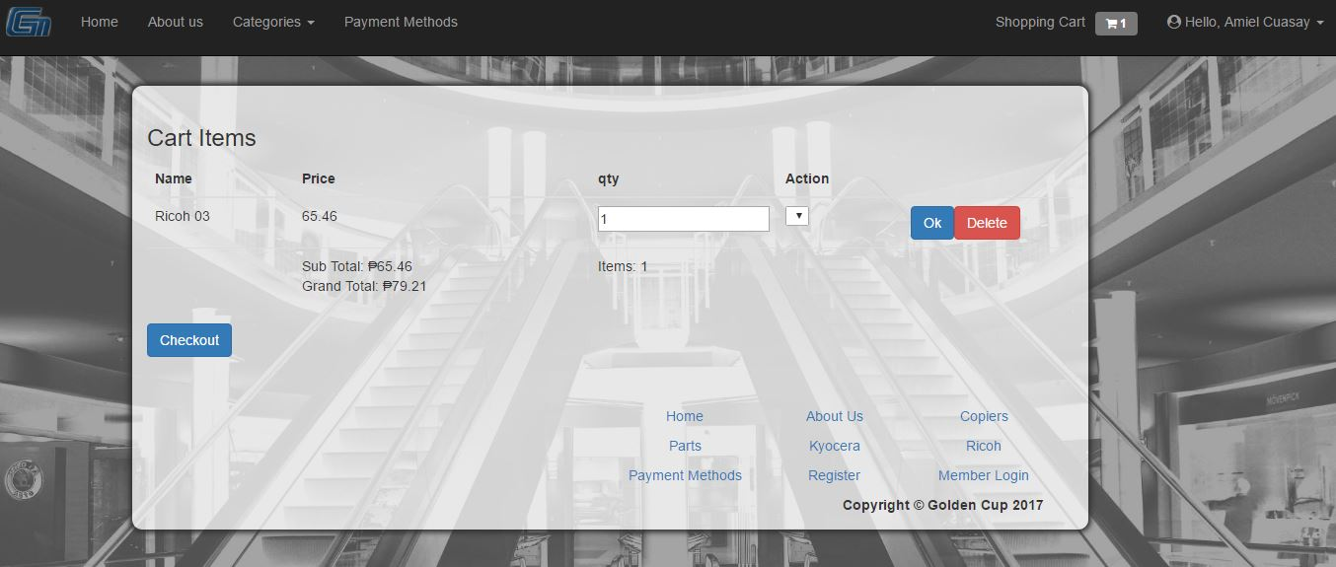

* On the rightmost column of the page after clicking the shopping cart is the actions column containing the edit button and the remove button.

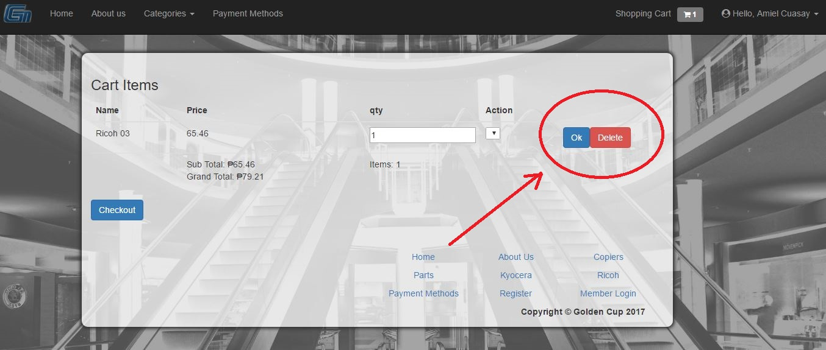

* Changing the number in the quantity column and pressing the edit button will edit the amount of that specific item in your shopping cart.

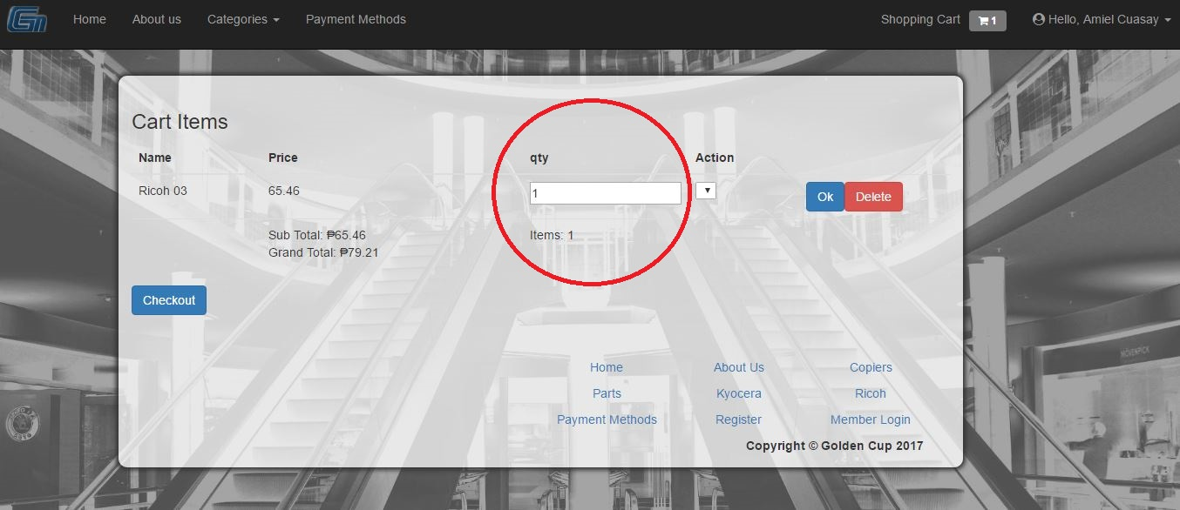

* Likewise, pressing the remove button will remove that specific item in your shopping cart.

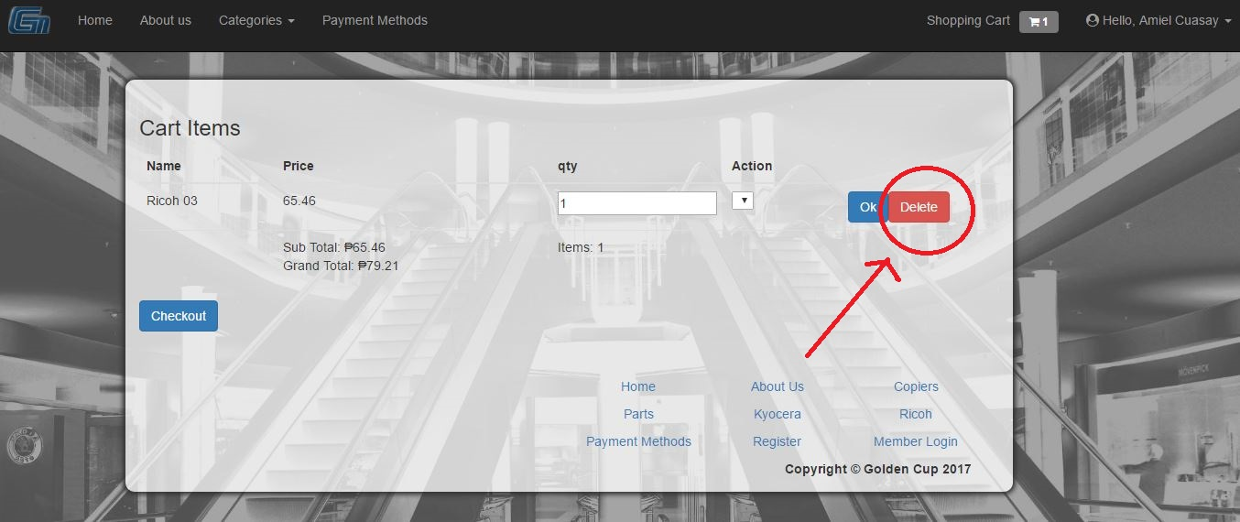

# Checkout

* To finally checkout the items in your shopping cart so you can proceed to pay for them, you need to access your shopping cart page by clicking the shopping cart icon.
* In the shopping cart page, on the bottom part of the page after all the shopping cart items is the checkout button.

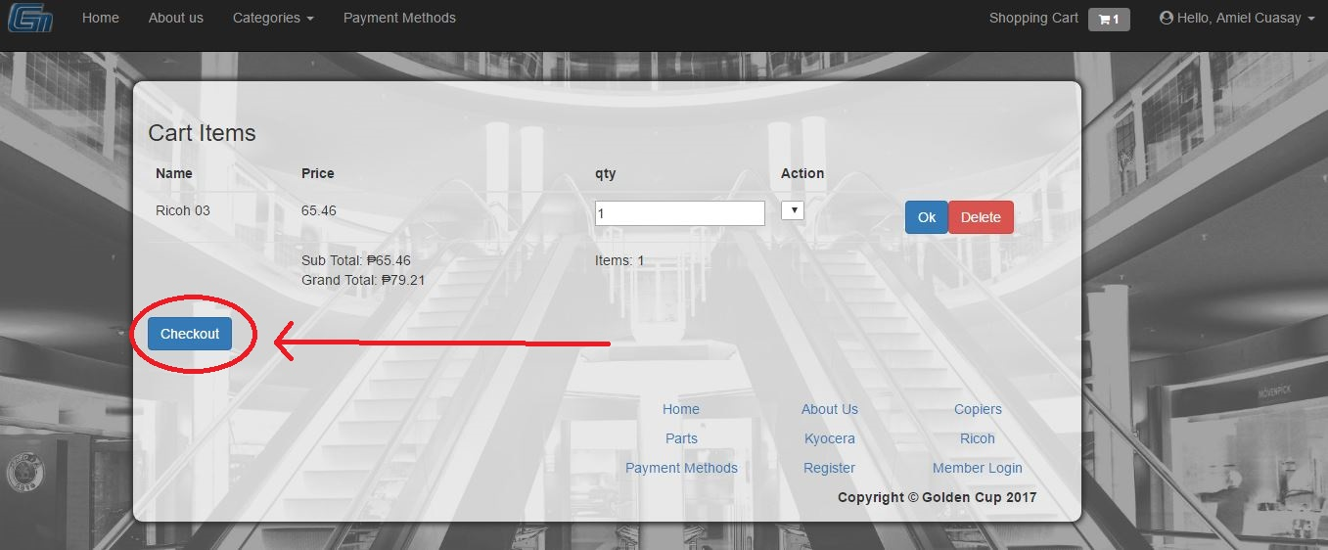

* After pressing the checkout button, if you are not yet signed in an account, you will be redirected to a page where you can choose to either sign-in your account, register an account, or to proceed without an account.
* After choosing and either signing in or registering and authenticating the account or proceeding without an account, you’ll be directed to a shipping details form which you’ll need to fill out to finish the checkout process.

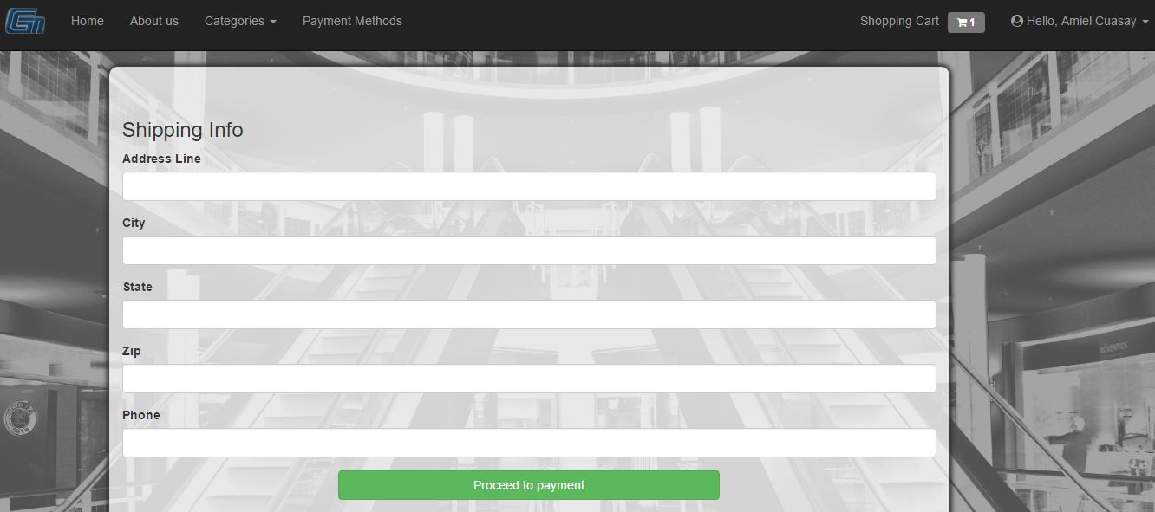

# Payment

* To reach the payment phase, you need to have accomplished the checkout process.
* After filling out the form from the checkout process and proceeding, you’ll be given either the choice of bank deposit or cash on delivery as payment options.
* When you have chosen your payment option, there will be instructions for your chosen payment